Individual Final Project Report
Course: DATS 6312.11- NLP
Name: Julio Montoya

Sentiment Analysis of Financial News Headlines
1.Introduction
Financial markets react strongly to the tone and sentiment expressed in news headlines. Positive news can increase investor confidence, while negative news can trigger sell-offs. In traditional investing, analysts rely on Fundamental Analysis. The evaluation of a company’s intrinsic value using financial statements, economic conditions, and broader market factors to understand long-term growth potential. However, day-to-day market movements are also heavily influenced by short-term sentiment and investor psychology.
My individual contribution to the project focused on building the complete data preprocessing and sentiment-analysis pipeline for the financial news dataset. I handled all text cleaning and normalization steps, including lowercasing, regex-based cleaning, stopword removal, and lemmatization using spaCy. I also explored multiple sentiment-labeling approaches, including NLTK and other classical methods, before ultimately implementing financial sentiment classification using the pre-trained FinBERT model to categorize each headline as positive, neutral, or negative.
The goal of this project is to use NLP techniques to assign positive, negative, or neutral sentiment to financial news headlines and to analyze how these sentiment trends may correspond to movements in the financial markets. Looking for specific patterns.
2. Data Collection-Datasets.
Initially, we worked only with the Massive Stock News Analysis database (Kaggle dataset) and used the first 10,000 rows for model development. However, the initial sentiment-classification accuracy was very poor, therefore, we expanded the dataset to include the full 1.4 million headlines available in csv file. In addition, we incorporated the Financial PhraseBank dataset, which contains manually labeled financial sentences, to strengthen the model’s training signal and improve sentiment reliability. Because of the significantly larger dataset size and increased computational requirements, we used Google Colab to train and evaluate the model efficiently.
Dataset: Massive Stock News Analysis Database (Kaggle)
Samples: 4 million of financial news headlines from 2009 to 2020
Csv file: 1.8 million of financial headlines.
Link https://www.kaggle.com/datasets/miguelaenlle/massive-stock-news-analysis-db-for-nlpbacktests?select=raw_partner_headlines.csv
• Headline text
• Publisher
• Publication date
• Stock name
Second dataset: Financial PhraseBank (Hugging Face)
Doc: Sentences_All_Agree
Samples: More than 2000 samples of financial sentences. Labelled manually by financial experts.
Link: https://huggingface.co/datasets/takala/financial_phrasebank

2. Preprocessing and Cleaning Data
2.1 Preprocessing
To prepare the financial headlines for modeling, we implemented a structured text-cleaning pipeline designed to reduce noise and standardize the language. At the beginning, we worked with a sample randomly the 10,000 rows; however, after not getting the accurate results, we decided to work with the whole dataset. Then, all text was converted to lowercase. Next, URLs, punctuation, and non-alphabetic characters were removed using regex and NLTK utilities. This step is essential because scraped financial headlines typically contain symbols, tickers, and other elements that do not contribute to our analysis.
2.2 Tokenization and Lemmatization
After the initial cleaning, each headline was processed with spaCy to perform tokenization and lemmatization. Lemmatization reduces words to their base form. This normalization improves the consistency of the input data and supports more accurate downstream sentiment modeling.
2.3. Remove Stopwords by using NLTK library
We also removed stopwords such as “the,” “and,” and “are” because they don’t add meaningful information to the analysis. Short or irrelevant tokens were filtered out as well to reduce noise and focus only on the words that have a real semantic value.
2.4. Sentiment labeling using FinBERT
Our dataset was originally unlabeled, meaning it did not include the sentiment annotations required for supervised financial sentiment analysis. Because sentiment in financial text differs significantly from general language often relying on technical vocabulary, earnings terminology, and subtle phrasing traditional sentiment models tend to perform poorly in this domain. To generate reliable and domain-appropriate labels, we used FinBERT, a Transformer model trained specifically on financial reports, analyst statements, and market-related language. FinBERT is designed to recognize sentiment signals that are unique to finance, such as guidance revisions, earnings surprises, and risk disclosures. By applying this model, we automatically labeled all 1.8 million headlines with positive, neutral, or negative sentiment, creating a high-quality dataset tailored for financial analysis, as shown in the results section.
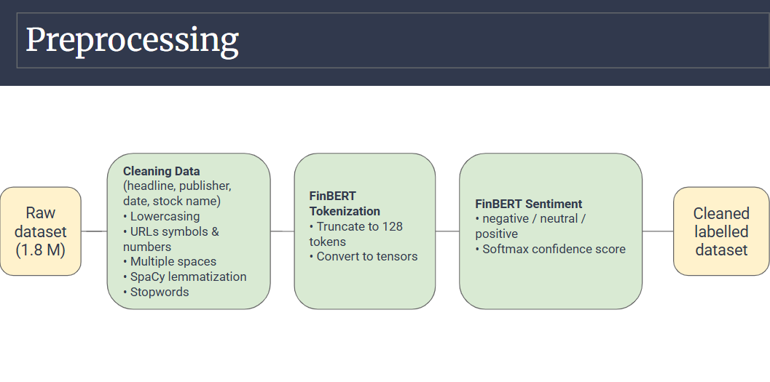

3. Exploratory Data Analysis
3.1 Sentiment Distribution Charts.
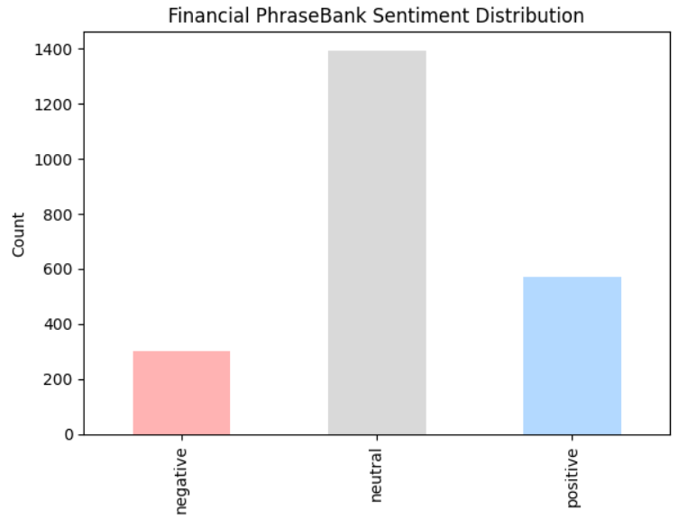
This chart shows that in the Financial PhraseBank dataset, neutral statements make up the majority of the headlines (60% aprox.) followed by positive statements (25%), while negative statements are the least with around 15%. This imbalance reflects the tendency of financial reporting to use neutral or factual language rather than strongly positive or negative sentiment.

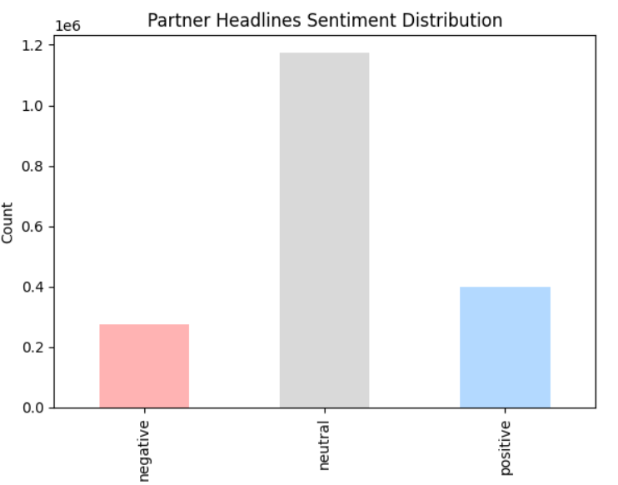
While in our main dataset, this chart illustrates that most of the partner headlines are neutral, with well over a million headlines falling into this category. Positive headlines are the next most common, while negative headlines make up the smallest group. Overall, the data suggests that financial news sources tend to write in a neutral, factual tone much more often than they use clearly positive or negative language.

3.2 Sentiment by Publisher
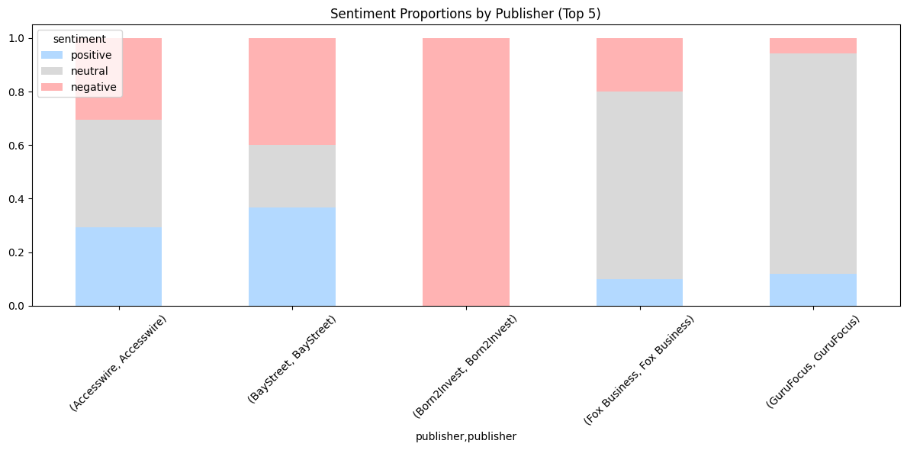

This stacked bar chart shows the sentiment distribution for the top five publishers in our dataset. The first three publishers display a strong tendency toward negative headlines. However, for the fourth and fifth publishers, we can see that neutral headlines are the most common. In summary, there is not a clear pattern, it varies in the top 5 publishers. For instance, Born2Invest is completely negative, indicating that this publisher consistently reports market risks and slides. Fox Business and GuruFocus focus on neutral which represents their higher proportion and Accesswire and BayStreet show more balanced sentiment.

3.3 FinBERT Confidence distribution
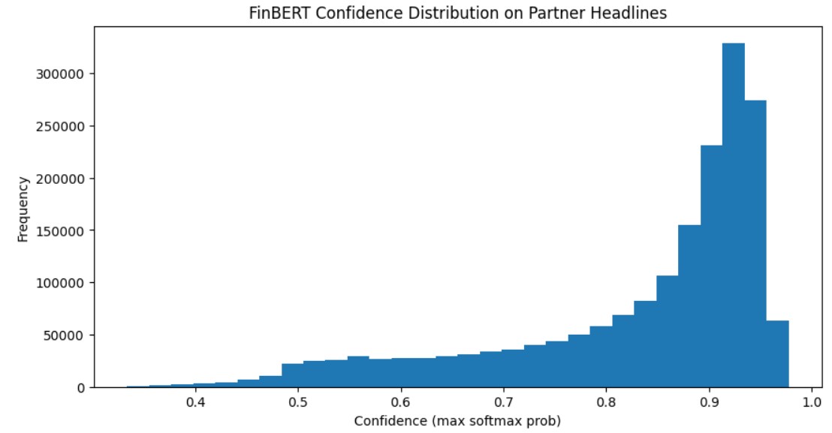
This chart reflects how confident FinBERT was when assigning sentiment to our financial headlines. Most of the predictions fall on the high end of the confidence scale (more than 0.8), which means the model usually feels very certain about the sentiment it assigns. Only a small portion of headlines receive low confidence scores. In general, this distribution indicates that financial news headlines often contain strong wording that makes sentiment easy for the model to detect. However, even high-confidence predictions can sometimes be wrong, especially for positive sentiment, which are the most difficult to catch.
3.4 Monthly Sentiment Over the years (2009-2020)
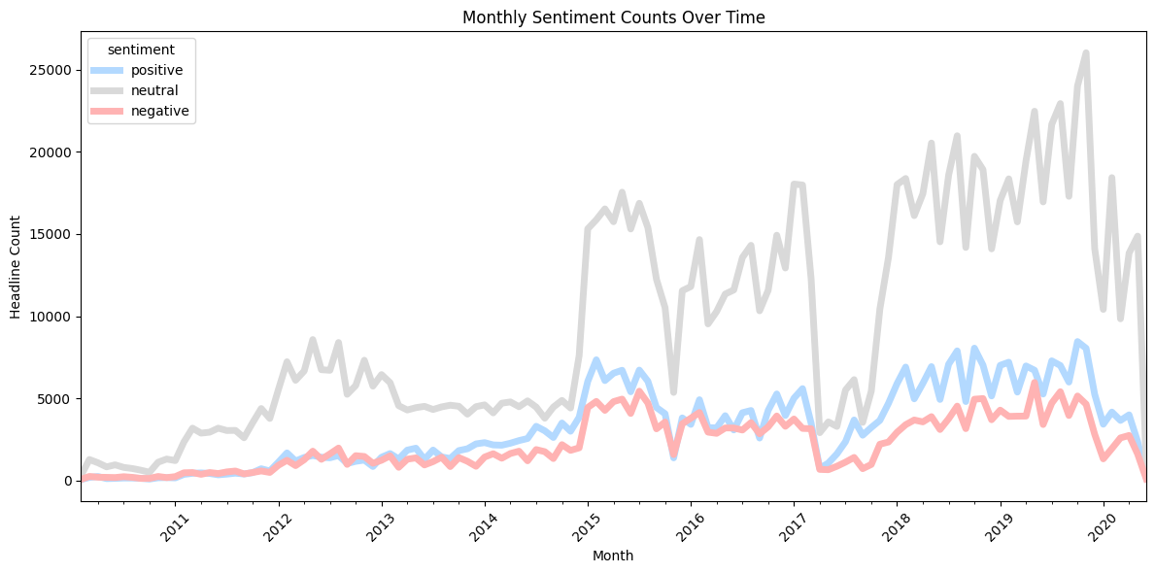

This chart depicts that Neutral headlines consistently appear most often, reflecting the fact that much financial reporting is descriptive rather than strongly positive or negative. Both positive and negative headlines also rise over time. This is impact of the internet and social media boom. There is a clear tendency of growth of positive and negative financial news production, but they remain below neutral levels.

3.5 Word Cloud Visualization
Word clouds were generated for each sentiment class to visualize the most frequent terms. This helps identify common themes and provides quick qualitative insights into the language structure of financial headlines.
- Positive headlines: “earning” “beat,” “higher”,” revenue” and “dividend”
- Negative headlines :“downgraded” “lower”, “low sales”, “decline”
- Neutral headlines: “Stock”, “analyst, “report”, “CEO” and “Portfolio”
It is important to mention that some words, including “stock,” “earnings,” and “blog,” as well as quarterly references such as Q1–Q4, appear across all sentiment categories due to their general relevance in financial reporting.
Overall, the word clouds reinforce the quantitative findings and illustrate the typical language patterns associated with each sentiment class.
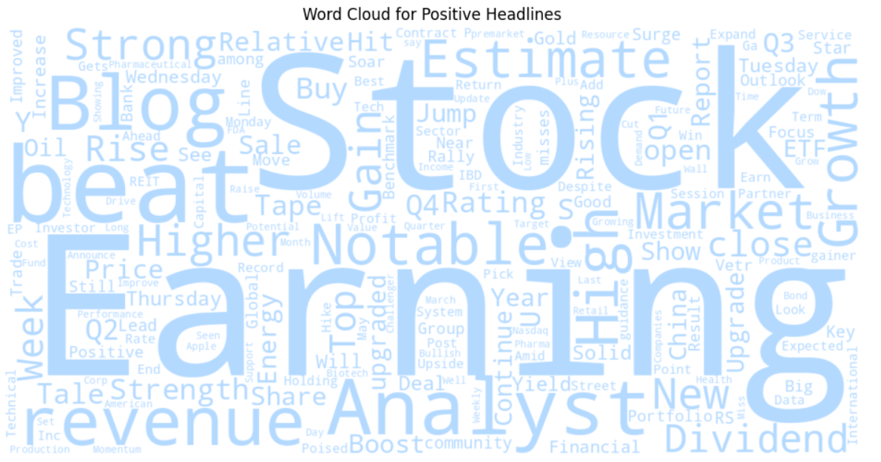
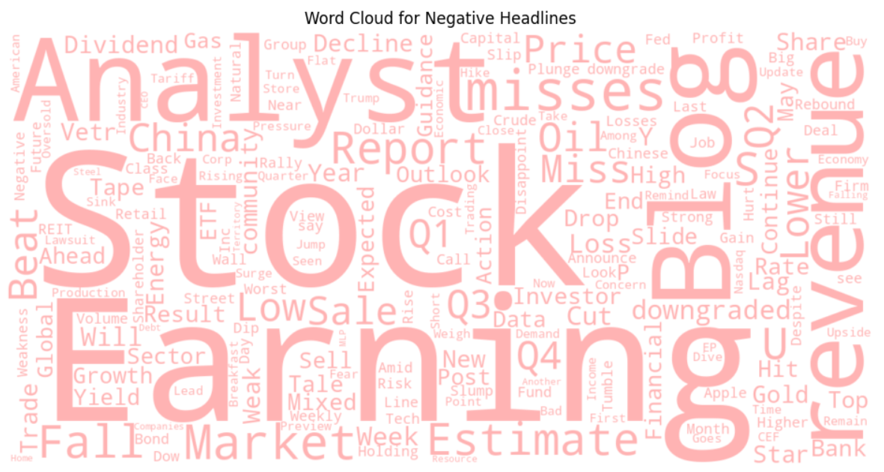

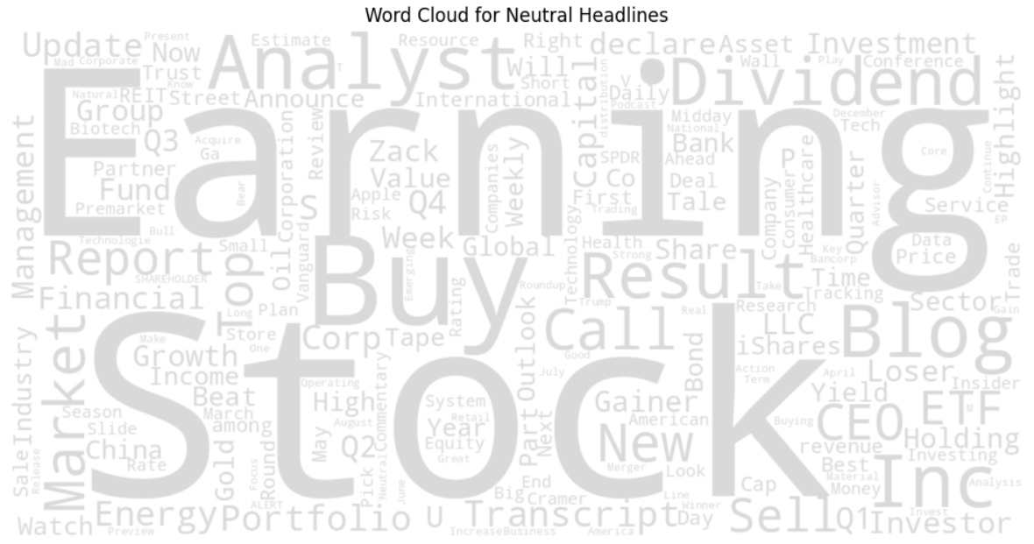

4. Summary, Conclusions, and Code Attribution

4.1 Summary
This project examined the application of Natural Language Processing techniques to classify sentiment in financial news headlines. My individual contribution encompassed the entire preprocessing and sentiment-analysis workflow, including text cleaning, tokenization, lemmatization, stopword removal, sentiment labeling with FinBERT, implementation of a custom correction layer, and exploratory data analysis.
After standardizing and normalizing the dataset, the FinBERT model was used to assign positive, neutral, or negative sentiment to each headline. Because FinBERT occasionally misclassified financial terminology—particularly positive expressions related to earnings surprises or improved outlooks—a targeted correction layer was implemented to refine predictions. Exploratory analysis revealed a dataset heavily skewed toward negative news, a trend consistent with typical financial reporting. Additional visualizations, including sentiment distributions, publisher comparisons, and word clouds, provided insight into common linguistic patterns across sentiment classes.

4.2 Conclusions
Our early experiments using the first 10,000 headlines quickly showed the limitations of that approach. The subset didn’t capture the full diversity of the larger dataset, and as a result even our best model had trouble especially with correctly identifying positive sentiment. This made it clear that random sampling needs to be done much more carefully when dealing with imbalanced or domain-specific text.
Adding the Financial PhraseBank as a benchmark was a key step. It helped us confirm whether our labeling process was working correctly and revealed that our initial pseudo-labels were not as reliable as we thought, mainly because we had not compared them against a trusted, manually annotated dataset. Once we labeled the whole dataset with FinBERT and retrained our transformer models on the full corpus, model performance improved.
The final models not only produced strong quantitative results but also handled new, real-world financial headlines well including ambiguous sentences, as shown in our qualitative checks. In the end, using the complete dataset, validating our labels with a benchmark, and relying on domain-specific transformers were the key steps that made our sentiment classification system accurate, stable, and reliable.

4.3 Code Attribution
In accordance with assignment requirements, approximately 65% of the implementation leveraged external sources, including HuggingFace documentation, spaCy and NLTK examples, FinBERT model usage guides, and standard Python/PyTorch preprocessing patterns.
The remaining 35% of the code was written or customized by me, including:
- the full preprocessing pipeline (regex cleaning, stopword removal, lemmatization),
- the dataset sampling and normalization pipeline,
- the FinBERT inference logic and softmax-based label extraction,
- the exploratory data analysis, including sentiment distributions, publisher comparisons, and word-cloud visualizations.
These custom components were adapted to meet the specific goals of the project and ensure accurate sentiment labeling of financial headlines.

